
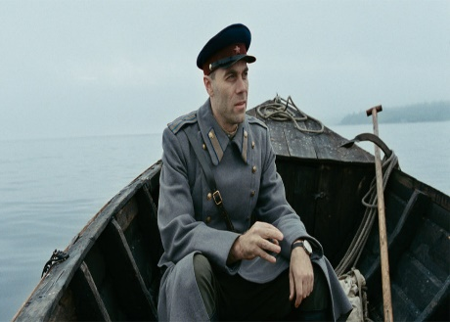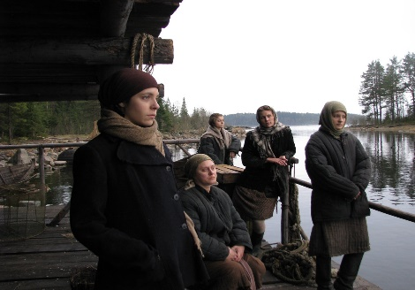 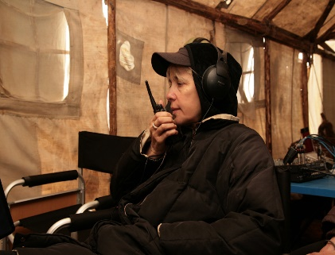(Source: IMDb, n.d.)
To mark the 75th anniversary of the end of World War II, you are invited to a screening of
One War
directed by internationally acclaimed Russian film maker, Vera Glagoleva (1956-2017),
who directed Ralph Fiennes in Two Women.
Tuesday 24 March 2020
Chapel Arts, Knapp Road, Cheltenham GL50 3QQ.
Doors open at 19.00 with drinks available from the bar.
19.30 a short introduction about Cheltenham’s evolving links with its Russian partner city of Sochi including plans for the Sochi International Film Festival and Awards (SIFFA)
taking place in Cheltenham in 2021.
Followed by this 90 minute film in Russian with English sub-titles
Based on real events set on a small northern island in May 1945, this engrossing drama portrays a little-known chapter of WWII history. With powerful humanistic themes, strong performances and impressive widescreen camerawork, One War tells the story of five Soviet women from German-occupied territories, branded traitors for bearing children fathered by enemy soldiers, awaiting evacuation from their remote island prison camp.
Tickets £7 in advance or £9 on the door
Tickets available from Chapel Arts website https://www.thechapelarts.com/
Or from Chapel Arts, open Wed – Sat 10am - 4pm. Tel: 01242 580077
We are grateful to Chapel Arts for hosting this event.
Proceeds will be shared between Chapel Arts and Cheltenham Twinning Association.

