An Entente very Cordiale
14/15 September 2018

“It was a dark and stormy night" is an often-mocked and parodied opening to an 1830 novel. Well, the night of 15 August 1943 was anything but dark and stormy; the weather was good and visibility clear, and it saw Halifax B Mk2 JD180 of 138 Squadron, based at RAF Tempsford, set off on a mission to drop arms, explosives and food to the French Resistance operating near the town of Annecy, situated very close to the border with Switzerland. The mission was also to drop leaflets onto the town.

The flight was unremarkable for most of the way but attempts to parachute the supplies to the Resistance were unsuccessful, apparently because of an absence of signals on the Alpine plateau that was the base area of the Resistance. The aircraft then turned to Annecy to drop leaflets. The pilot made two passes over the town, but disaster struck when an Italian Alpini corporal on sentry duty with his unit billeted in the area, fired at the low-flying aircraft. A shot severed an engine coolant pipe and a fire ensued. It seems likely that, in the stress of the situation, a serviceable engine was cut, and now on just two engines, the aircraft started to lose altitude. The pilot wanted to land on the lake close to Annecy but first had to jettison canisters of arms and explosives. However, with the aircraft heading towards the town, it clipped a power or telephone pole and crashed onto a house close to the Tasset Bridge in the Meythet suburb.

The aircraft broke in two, damaging another house. In spite of the risk of fire from hundreds of gallons of aviation fuel, two local inhabitants bravely managed to recover the pilot who had been thrown clear but was burned and injured. The other six crewmen all perished, as did a number of French civilians, including two children, on the ground.

After tending to the pilot’s injuries, the people of Annecy managed to smuggle the lone aircrew survivor across the border to Switzerland from where he was repatriated back to the UK via Spain. The bodies of the other six aircrew were recovered by Italian forces who delivered them to the civilian cemetery in the town and, by all accounts, departed as quickly as possible.

The crash was a liberating element and a moment of expression for the population of Annecy, which had been rather Vichy in its sentiment until then. A recent French account states "When there was the burial of the crew, there were 5,000 people who came to attend the funeral. They shouted ‘Long live England’, ‘Long live Canada’ and ‘Long live the allies’. In the days that followed, there was a queue all along Cran Avenue to drop flowers at the crash site.”

Today, Annecy is twinned with the town of Cheltenham and, to commemorate (a few weeks late) the events of 75 years ago, a small delegation from Cheltenham was invited to participate. The delegation consisted of the Cheltenham Chairman of the Twinning Committee, an Honorary Alderman and former Mayor, the Chairman of the Cheltenham Branch of the Royal British Legion (Wg Cdr Roy Roberts RAF retd) and myself (Mike Bryant) – Chairman of the Cheltenham Branch of the RAFA. We were joined in France by Dr Bryan Pattison, Chairman of the Swiss Branch of the RAFA.
The warmth, hospitality and generosity of our French hosts was exceptional and could not have been bettered. This demonstration of friendship and recognition of the contribution of the RAF during some dark days that our two nations have shared was apparent throughout our time there.

After arriving at Annecy on 14 September, meeting our French hosts and having lunch, the by now Anglo-French party visited the Alpine plateau that was the operating base for the Maquis intended to receive the air-dropped supplies. I learned that the term “Maquis” referred to those members of the “Resistance” who were armed and carried out military operations against the Germans. Other members of the “Resistance” opposed the German occupation by, for example, printing and distributing leaflets, causing disruption, vandalism and propaganda.

The plateau was surrounded by mountains, making it an almost impregnable natural redoubt, with the Maquis numbering around 475, mostly young men led by professional French military officers. However, the Germans eventually attacked the area with over 14000 men, supported by aircraft and artillery, and killed large numbers of their opponents. Those that were left were ordered to disperse and join Resistance units in other parts of France. As one French member of the party at the commemorations ruefully remarked, being led by officers whose background was that of the French military academy St Cyr meant that the concept of asymmetric warfare would never have been adopted, and a conventional battle was doomed to defeat.

The next day, we visited the Meythet cemetery to lay wreaths at the graves of Fg Off Sydney Congdon (navigator), and Flt Sgt Francis Pollard (air gunner). About a 100 civic dignitaries and local citizens attended the commemoration service there, with the British and French national anthems being played. The cemetery was beautifully kept and a memorial site with the headstones and a plaque bearing the names of the other members of the crew holds a prominent position. For reasons that are not known, the other members of the crew are buried at Rhône, some 100 miles away from Annecy. They were:

Plt Off Robert Peters (wireless operator/air gunner)
Sgt Frederick Davies (flight engineer)
Sgt John Maden (dispatcher)
Fg Off Roderick Mackenzie (bomb aimer)
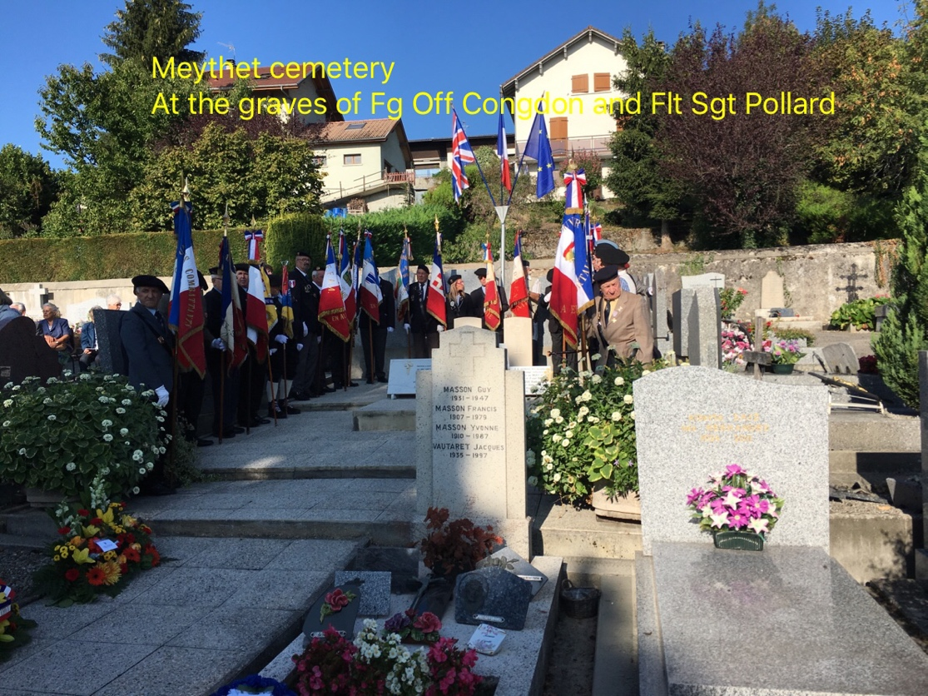
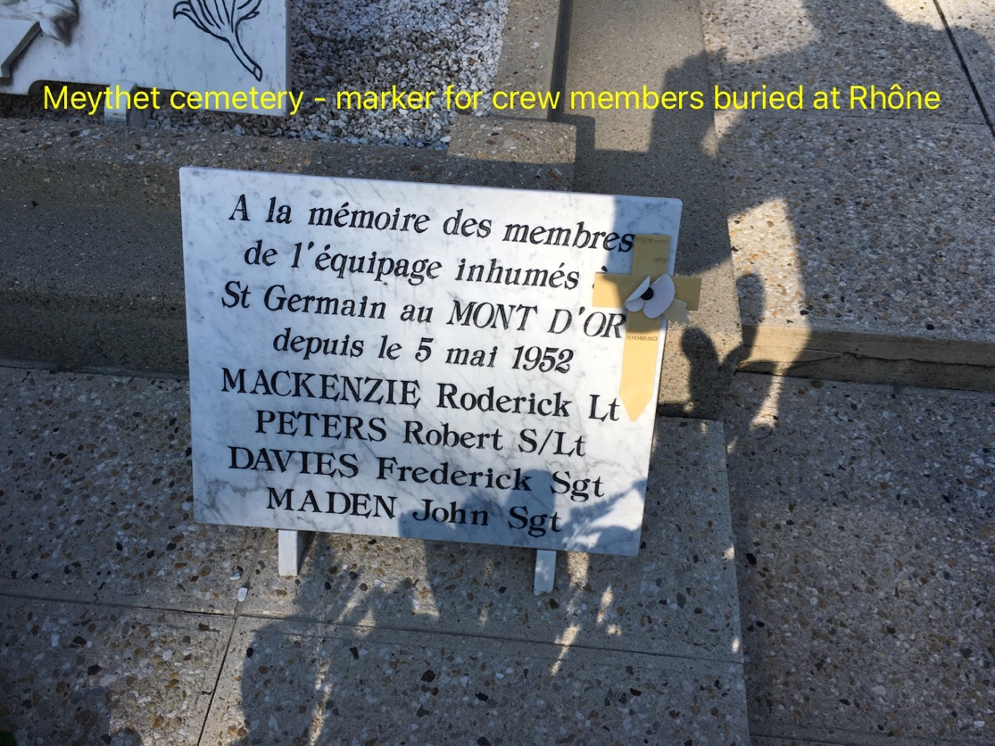

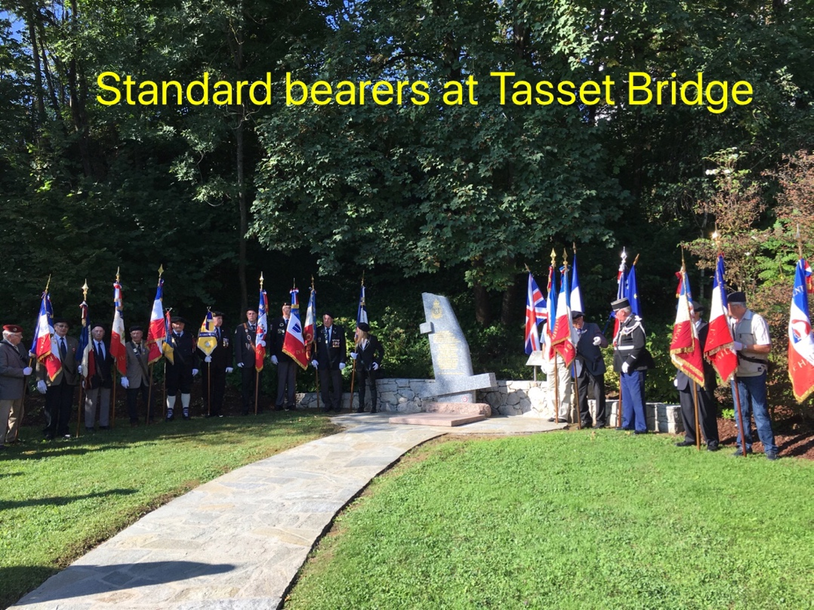
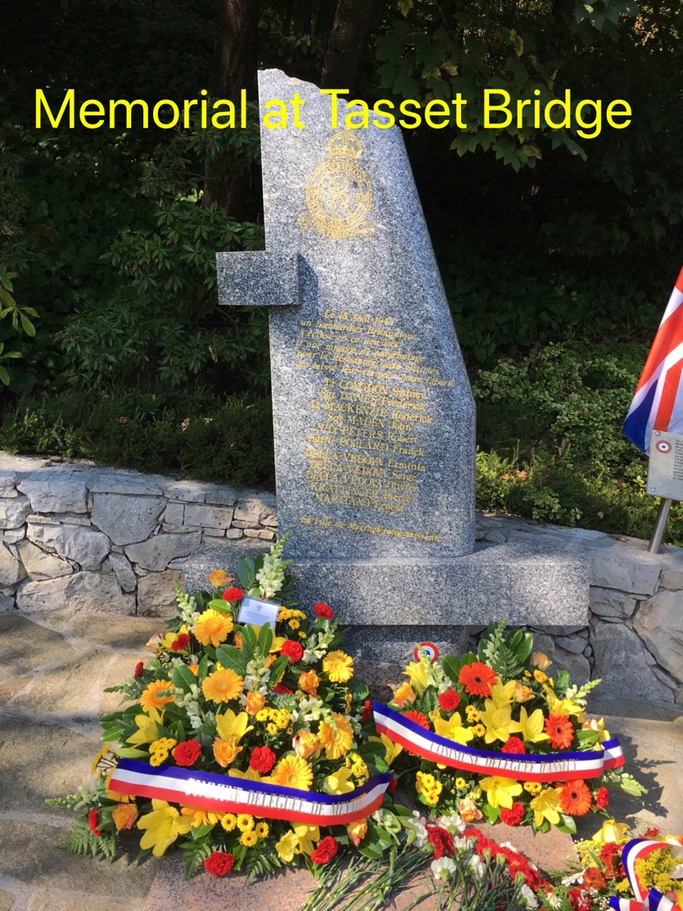
We then moved to the Tasset Bridge where there is a memorial garden to the event, with an impressive marker stone describing what happened and listing the names of the deceased aircrew and local civilians. As with the Meythet ceremony, the local people turned out in force and it was clear that the the crash had great significance for the town. A notable feature of the commemorations at both sites was the attendance of over 20 standard bearers from a variety of French ex-Service and old-comrades associations. It was also moving that a number of children participated, keeping memories alive and giving hope for the future. At the conclusion of the commemoration at the Tasset Bridge, we moved to a civic reception hall where there was a display of the aircraft, a description of the crash and brief biographies of the crew.
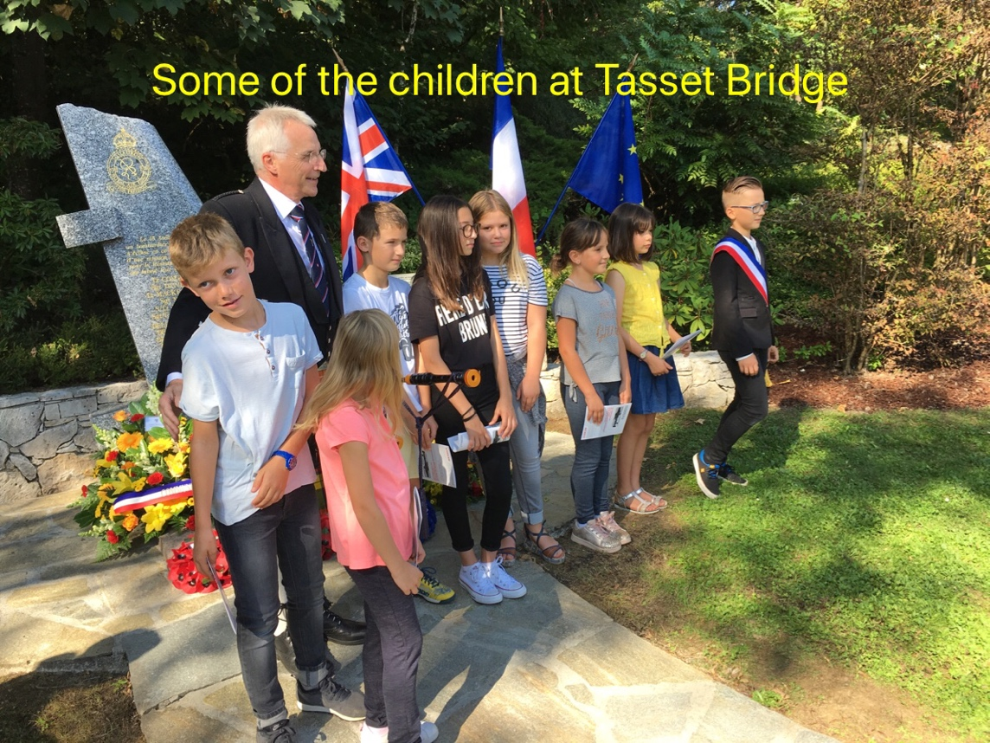

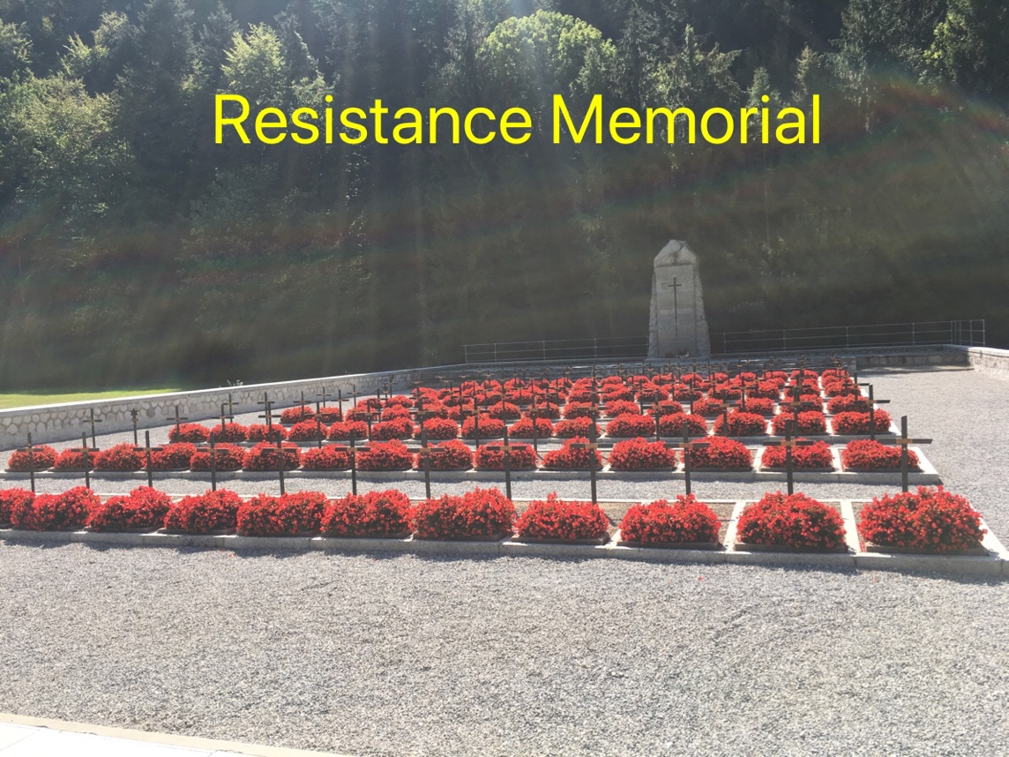
Later in the day, we visited the Resistance Memorial and Museum on the outskirts of town. As with all the places we saw, the reverence and care that the local people show for what were unpleasant events was remarkable, as was their appreciation of the part that the RAF played in their interests all those years ago.

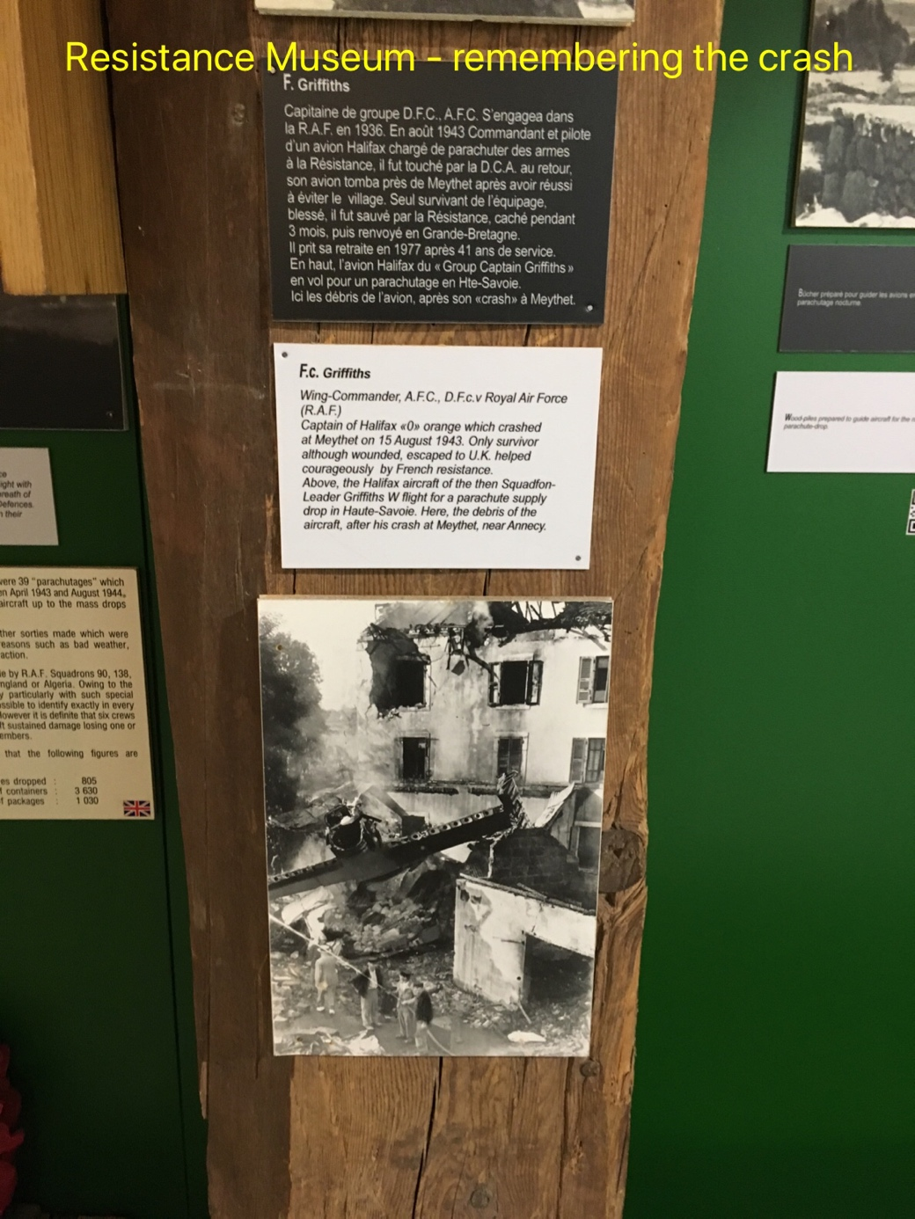

After arriving back in England, the pilot who survived the crash, Sqn Ldr Frank Griffiths, resumed his RAF duties and served until he retired as a Gp Capt in 1977. He wrote a number of books; in one he described his escape from France and his time with the Maquis, and in another he recounted how he was recalled to England just before the Japanese invaded Singapore, otherwise, in his words, “I would have finished up in a grave beside the notorious Thailand to Burma railway”.
He clearly had a charmed life!

There is much to divide us, both in our country and in Europe, but it was truly humbling to discover just how much one event, tragic in itself, has established enduring bonds of friendship between two towns – one English and the other French. Moreover, it cemented the RAF in the admiration, respect and affection of a community that is determined not to forget the sacrifice that was made.

The historical detail in this report was derived from multiple sources, too many to list, but mostly on the internet. They include a number of contradictions and ambiguities but the main facts seem to be firmly established. I have also drawn on research carried out by Wg Cdr Roberts.

